**Identification of Pre-processing Technique for Enhancement of Mammogram Images**

**Abstract**

Pre-processing is one of the preliminary stages used for mammogram image enhancement to aid an early identification of suspicious lesions and **micro calcifications.** Nine image preprocessing techniques are considered here for mammogram images. These techniques are implemented using Matlab. The results obtained are compared on the basis of Peak Signal to Noise Ratio (PSNR) for a set of 30 mammogram images. A high value of PSNR indicates better suitability of the pre-processing technique for further image processing. Anisotropic diffusion and Median filtering are suitable for noise removal. Power-law transformation, morphological processing, and un-sharp masking are giving better enhancement results in terms of achieved PSNR values as compared to other pre-processing techniques analyzed here. These identified pre-processing techniques, chosen carefully may give better results for further identification of masses, calcification, architectural distortion, bilateral asymmetry and aid in early detection of breast cancer.

**I. INTRODUCTION**

Image enhancement is a crucial step in most of the image processing applications. Enhancement means improving the visual quality of image for better interpretation and human perception. A number of image enhancement techniques exist but as far as mammogram processing is concerned, the techniques of interest are the ones that do not degrade the quality of image or modify existing information content in the image. One or more attributes of the image are selected and modified in the enhancement process. The enhancement processes are categorized in two domains: spatial domain and frequency domain. Techniques belonging to the first category [2] are directly applied to the image pixel values to get desired enhancement. For the second category, Fourier transform is obtained for its frequency domain representation. After doing enhancement operations in frequency domain, Inverse Fourier transform is carried out to get the resultant image in spatial domain. Image enhancement may include manipulation of image intensity and its contrast, reducing the levels of noise present, background removal in order to avoid any artifacts, filtering, edge sharpening etc. Enhancement may involve operations that are applied only on the selected region i.e. Region-of-Interest (RoI), in the image. Pre-processing of mammogram is essential for increasing the contrast between image background and selected RoI and to sharpen the edges or boundaries of suspected lesions. In this paper nine image pre-processing techniques are explored for better results suitability in case of mammogram images. The rest of the paper is organized as follows: section II presents review of related literature. Image pre-processing techniques considered are presented in Section III. Results are presented in Section IV. Finally, conclusions and future work are given in Section V.

**II. REVIEW OF RELATED WORK**

The common anomalies indicative of cancer in breast are **masses, micro-calcifications (MCs) and architectural distortion.** A breast mass could be defined as space occupying lesion seen in at **least two different projections or as a localized lump in the breast [3].** A mass is parameterized according to its shape, size, location margins and density etc**. Circular or oval shaped mass are generally considered as benign whereas masses with spicules tend to be malignant.** Micro-calcifications represent one of the earliest signs of breast cancer. **These are small deposits of calcium (and related) salts representing either warnings of malignancy or just benign formations. They are encountered in approximately 25% of mammograms and appear as bright spots or clusters of such spots, due to the high X-ray attenuation factor of calcium** [4]. Numerous approaches for image enhancements using Histogram processing are available. It **includes histogram equalization, adaptive histogram equalization and local histogram processing** [5]. **Adaptive histogram equalization is explored in this paper because of improvement in the appearance of images.** For a dark image histogram would be oriented towards the lower gray scale values. It means the entire image detail lie in the dark end of the histogram. **To obtain uniform distribution of gray levels, stretching of gray levels at the dark end is required.** Direct application of this method often results in the enhancement of noise present in the image. Contrast-limited adaptive histogram equalization (CLAHE) could be used to solve this over enhancement problem [6]. Histogram Modified Contrast Limited Adaptive Histogram Equalization (HMCLAHE) is another variation of this technique proposed in [7]. It adjusts the level of enhancement giving a strong contrast image and also highlights the local information present in the original image for better interpretation. In [8] an image enhancement algorithm based on edge detection is used to preprocess mammograms. The proposed algorithm was applied on preprocessed mammograms. It helped to get more details from images and lesions were clearly differentiable from background. Morphology is the science of structure and shapes. It could be used as a tool for image processing by extracting and representing regions and shapes of objects in images. Image enhancement, detection and segmentation of objects are some of the application areas of morphology [9]. **There are two simple operations called erosion and dilation on the basis of which a large number of filters can be designed and expressed**. Many image processing operations involving enhancement makes use of oriented filters. In this same filter is applied over again by rotating it at different orientations under adaptive control. One can remove noise and enhance oriented structures by angularly adaptive filtering. In [10] authors have used the steerable features of derivatives of Gaussian for image enhancement.

**III.IMAGE PRE-PROCESSING TECHNIQUES**

The pre-processing techniques described in this section have been applied on 25 images. RoIs are marked on the images by radiologists. These marks don’t contribute or affect the outcome of pre-processing techniques considered in this

work. It is indicated that the test images are taken from [11].

A. Contrast Stretching

Image may result into low contrast because of poor background lighting, lack of dynamic range in the imaging sensor, improper setting of focus etc. at the time of image acquisition [2]. Contrast stretching is used to increase the dynamic range of gray levels in the image being processed. Contrast stretching is considered here because mammograms generally have low contrast. It aids in identification of suspicious regions in the mammogram $Contrast stretching is done on the basis of (1)

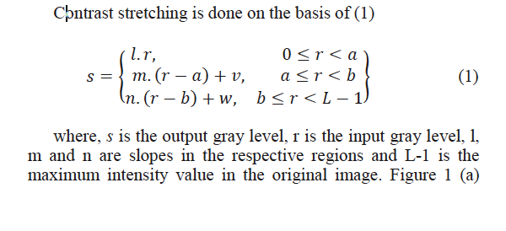

B. Power-Law Transformation

The power law transformation can also be used for improving the dynamic range. It can be expressed as a set of nth power and nth root curves. The transformation is represented mathematically by



where, s is the output gray level, r is the input gray level, c is constant and 􀈖 is the correction factor. It is also called as gamma correction [2]. Varying the values of 􀈖 will give transformations corresponding to different enhancements levels. Figure 1 (c) shows one of the power law transformed image as a sample output.

C. Histogram Processing

Histogram of an image provides enormous information about the image. It gives an idea about the appearance of the image and is defined as a plot of the relative frequency of occurrence of various gray levels. Histogram of a digital image with intensity levels in the range [0, L-1] is a discrete function given by (3)



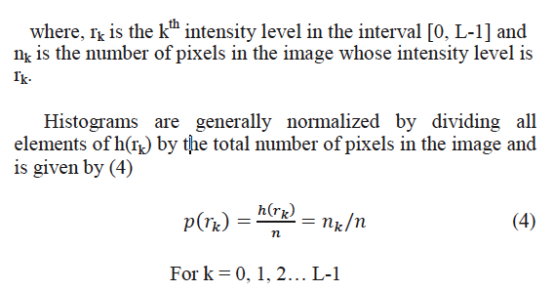

D. Un-sharp Masking

It is a common method of pre-processing employed for sharpening. It works by subtracting the smoothed image from original. Thus it enhances high frequency components like edges in the image and attenuate low frequency information giving a much sharper image [12]. This may make microcalcifications more prominent in the processed mammogram image. Un-sharp masking is performed using (5)

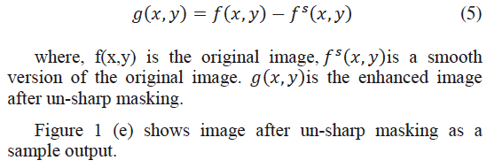

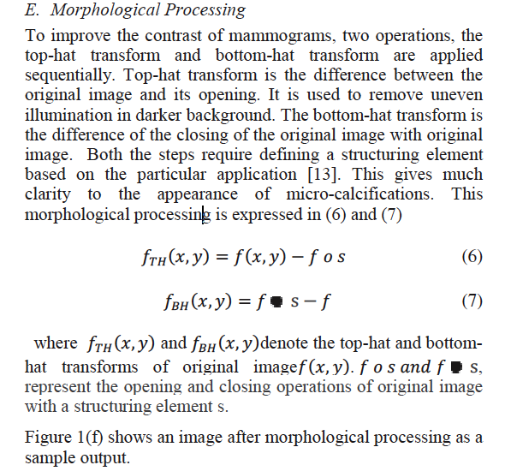

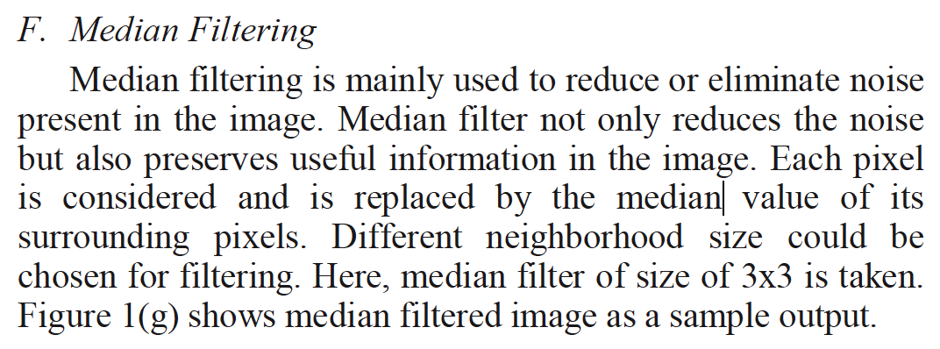

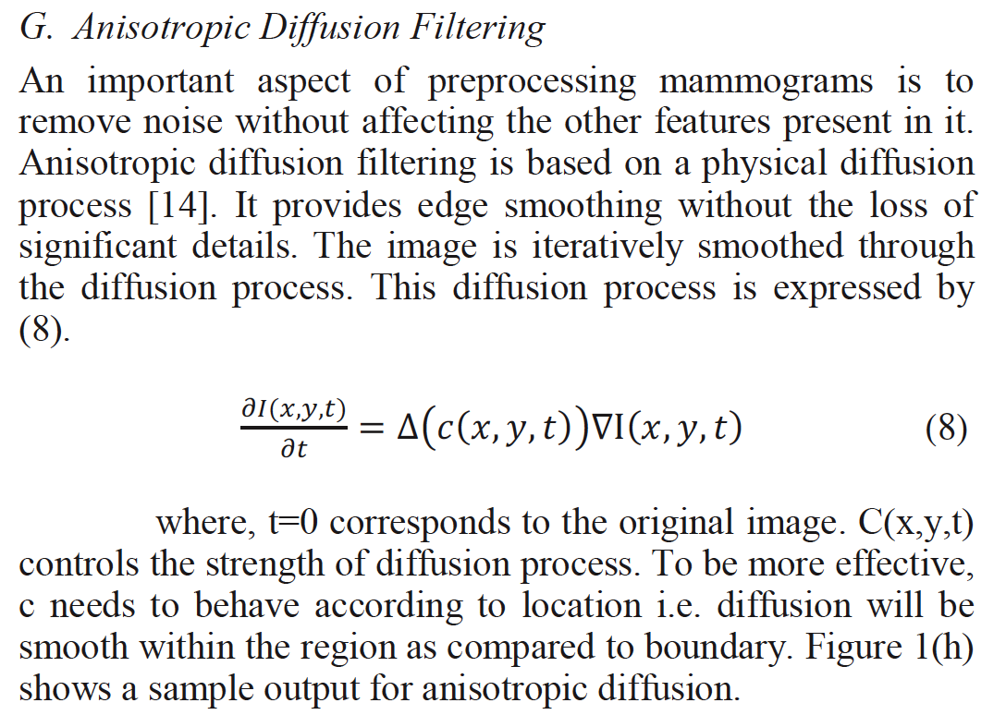

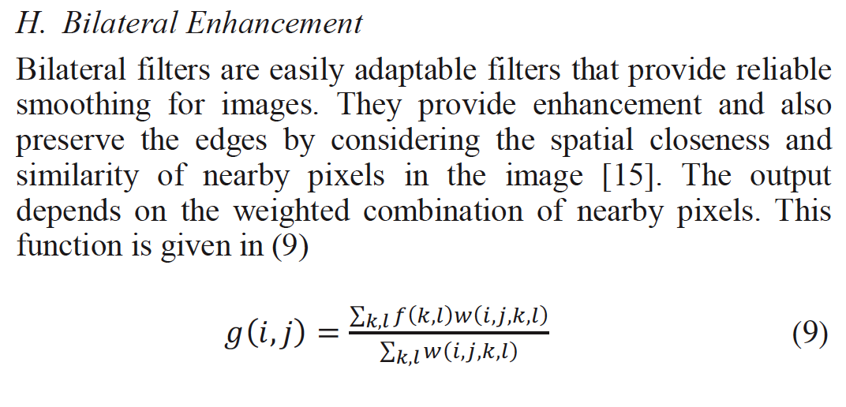

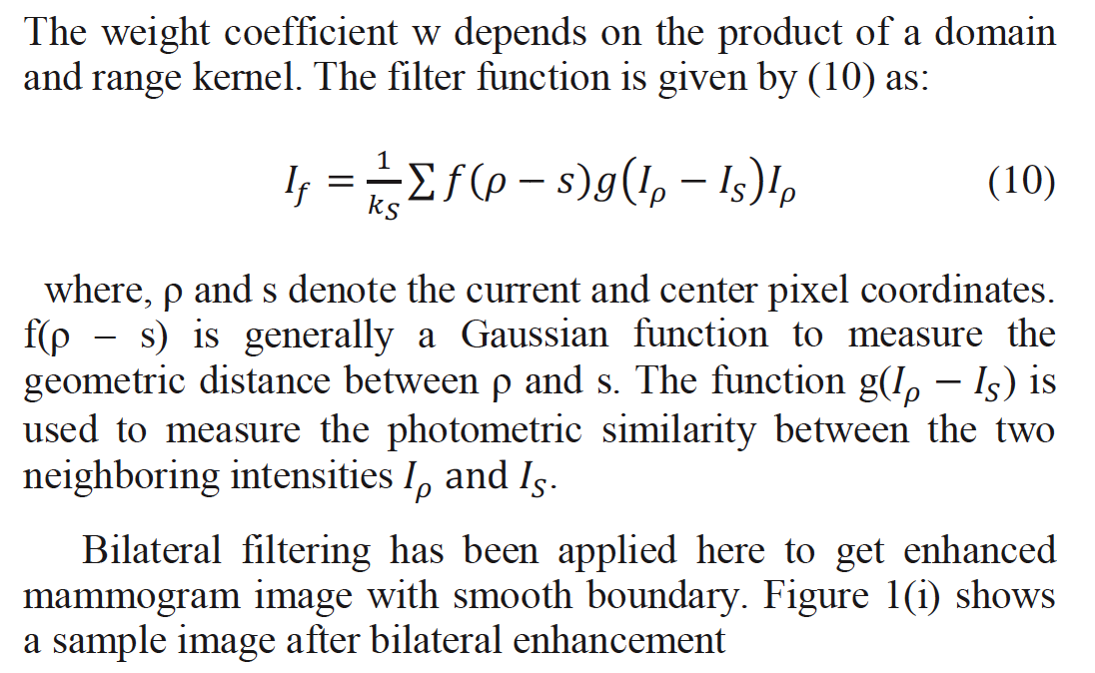

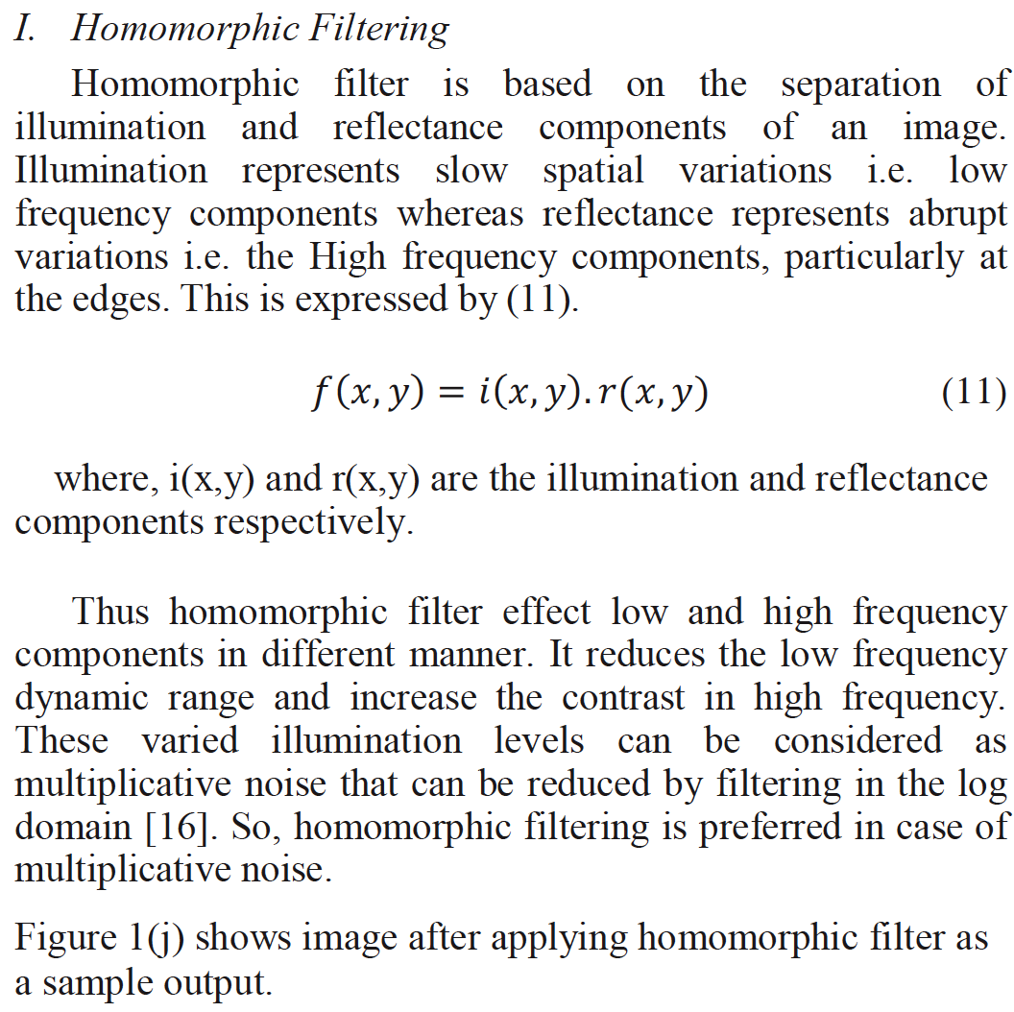

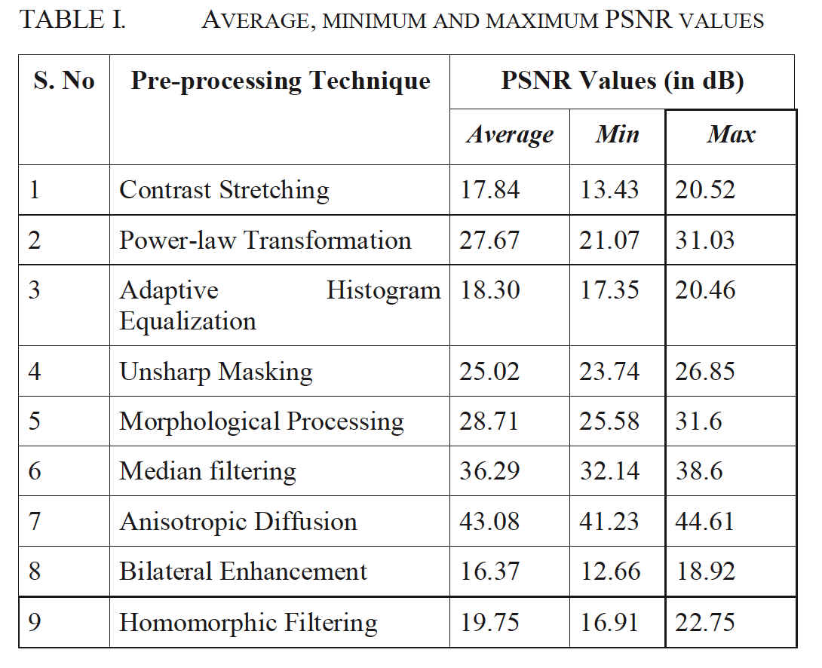

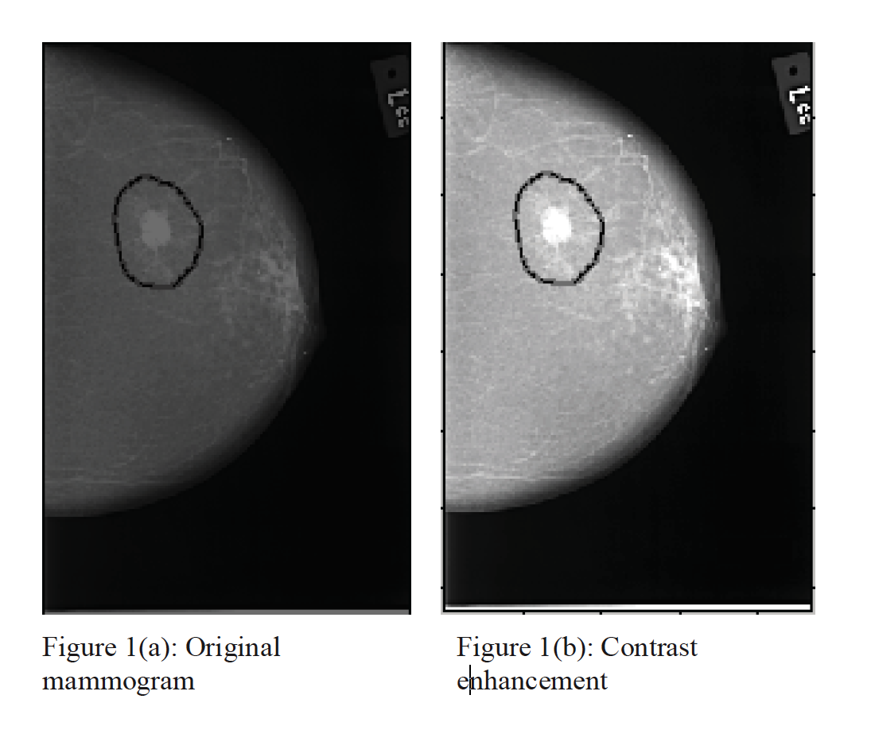

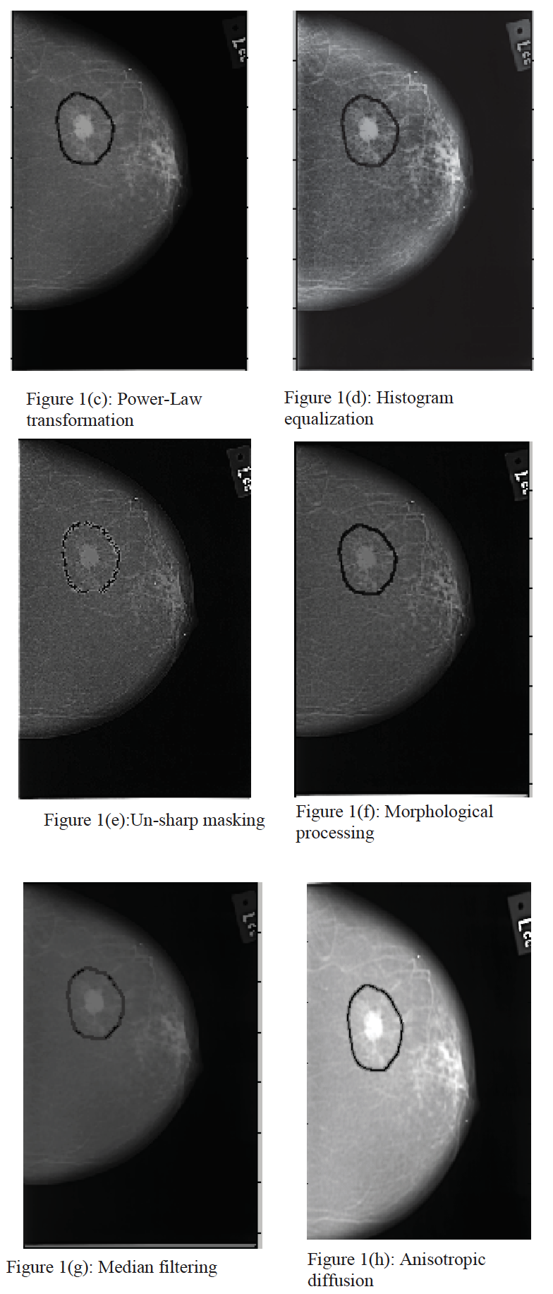

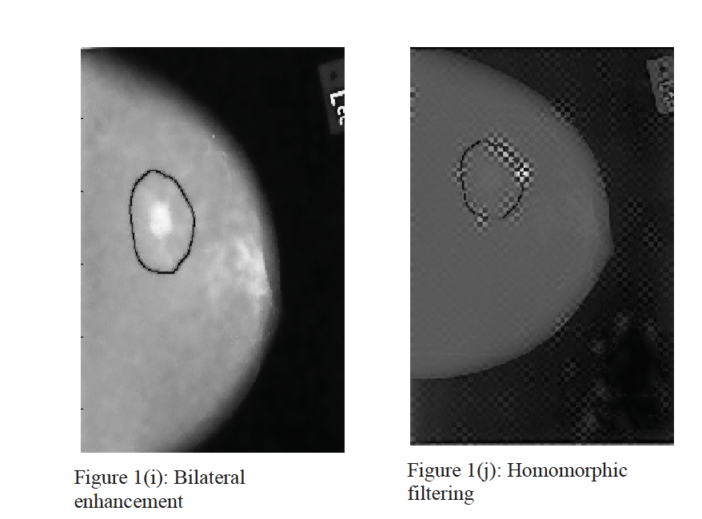

V. CONCLUSION

In this paper, nine image pre-processing techniques namely contrast stretching, power law transformation, histogram processing, un-sharp masking, morphological processing, median filtering, Anisotropic diffusion, Bilateral enhancement and Homomorphic filtering have been considered to identify its

better suitability to mammogram images. These pre-processing techniques have been tested on a set of 30 images and the result shows that anisotropic diffusion, power-law transformation, un-sharp masking, morphological processing and median filtering are giving higher PSNR values. So these techniques will be more suitable in pre-processing stage of mammogram images. The identified pre-processing techniques may be followed by segmentation, post processing, texture analysis, feature extraction and classification to yield better results. The future research will be carried out to improve the early identification of masses, calcification, architectural distortion and bilateral asymmetry for detection of breast cancer by using these identified pre-processing techniques.